**Alternatives to The Windowsill**

**Determining Optimal Heat Reduction Configurations for The Raspberry Pi V3**

Dylan Loader

April 10th, 2017

1. **Abstract**

Efficiency and longevity has is an important part of modern technology; with a growing interest in small form factor low cost electronics, it is important to understand how different conditions affect the internal temperatures of these devices. In this study we attempted to determine which physical configurations can help to reduce central processor heat accumulation in Raspberry Pi boards, by using a multiple factor factorial design. In this experiment we coded a Python 3 program to compute the numbers in the range from 0 to n. Treating the code as a block factor we ran three different program lengths with combinations of heat sink (on/off), and thermal paste (CTRL,TG4,NTH1,AS) while measuring the difference between before and after running the program. After running statistical analysis on the data we collected, we found that only the heat sink presence was important in reducing heat accumulation. Therefore, users of small form factor electronics should seek to apply a heat sink to their devices to reduce heat accumulation and thus increase the efficiency and longevity of their devices.

1. **Justification and Description of Experiment**

Today there is persistent advancement in the miniaturization of electronic components and thus the electronic systems composed of these components. It is important for designers, manufacturers, and end users to balance price, aesthetic, and quality to produce and consume the best possible products. Attempting to balance these factors is often unsuccessful which leads to grave consequences. Samsung had a failure recently with their operating conditions of an electronic device which is expected to cost them around “5.4 billion [USD]” (Swider 2016). In our experiment we have chosen to approach a much simpler problem within the consumer electronic market. With over 10 million Raspberry Pi units being sold, primarily to hobbyists, it is a market in which this research is pertinent and easily implemented (Upton 2016).

In the process of our experiment we planned to determine some possible methods to reduce the heat accumulation in the CPU (Central Processing Unit) of small form factor computer hardware. We have identified possible factors which affect heat accumulation to be ‘paste type’, ‘fin’, and computation length of the program we are running as a block factor.

For this experiment we chose a Raspberry Pi 3 Model B, which as of today is the most recent full form Pi. The response variable of interest was ‘temperature increase’. To determine temperature increase we measured the difference between initial temperature and final temperature after running a fixed length computer program. For each of the combination of treatments under each block we ran the computation until we had over thirty positive differences, we then took the sample mean of those thirty or more measures as a single measurement to assure approximate normality under the C.L.T. for an accurate measure of the average temperature increase resulting for each treatment under the fixed block. The internal measurement, taken by the Raspberry Pi were not constantly updated while the program was running because that would cause an increase in the computational load as a nuisance factor. Since the computation run times were often concurrent, and the internal temperature measurements accuracy may not be completely accurate, we removed all differences that were negative or zero before analyzing the data.

When choosing blocking factors we determined three lengths n = 5000, n= 10,000, n = 15,000, which gave measurable differences in temperature change while still keeping the CPU within a safe operating temperature for longevity. The second factor we considered was thermal compound type. Although compounds can be greases, pastes, or adhesives we chose to denote them as pastes for simplicity. We chose a control(CTRL) consisting of the base adhesive attached to the fin by the manufacturer, with the corresponding no fin treatment being the CPU with no paste or adhesive applied. For the three other pastes we chose TG-4 Thermal Grease(TG) made by Thermaltake, NT-H1 thermal compound(NTH) made by Noctua and Artic Silver 5 thermal compound(AS) made by Artic Silver. We one had one fin available for the CPU so we denoted the levels simply as (On) and (Off) for whether the fin was mounted or not.

1. **Design and Data Collection Methodology**

Initially we considered a running a 4X2 factorial design under three blocks with replication. Although the large number of measures required would not be feasible under our time constraint. To collect a singular measure of thirty positive differences of a single combination under block (15,000) often took a few hours. Requiring replication would most likely provide an increase in the test’s power, but we were not able to find a working power calculation for our model so we have decided to rely on randomization within blocks.

To begin the experiment we set the first block as fixed and set a pseudorandom seed of 9001 in R, and sampled for each fin-paste combination as follows:

set.seed(9012)  
treatment_selections <- c('tg4_fin','tg4_no_fin','nth1_fin','nth1_no_fin',  
 'as_fin','as_no_fin','no_treat','just_fin')   
block1_order <- sample(treatment_selections)

Continuing this process for each block we received the following table for run orders:

Table 1: Run Order for Sampling

|  |  |  |  |  |  |  |
| --- | --- | --- | --- | --- | --- | --- |
|  | Block I (5000) | | Block II (10,000) | | Block III (15,000) | |
|  | Fin On | Fin Off | Fin On | Fin Off | Fin On | Fin Off |
| TG | 8 | 1 | 8 | 2 | 8 | 2 |
| NTH | 4 | 6 | 7 | 1 | 1 | 6 |
| AS | 2 | 5 | 5 | 4 | 3 | 7 |
| CTRL | 7 | 3 | 6 | 3 | 4 | 5 |

Based on our randomization we fixed block 1 and began by running treatments until we had at least 30 positive differences. Once all treatments had been run in the above order we changed the block and repeated the same process for each of the three blocks.

**3.1 Statistical Model**

The model of interest for our data is:

$$y_{ijk}= μ+ τ_{i}+γ_{j}+β_{k}+{{(τγ)}_{ij}+ε}_{ijk}$$

Where:

* μ *is the grand mean*

$τ_{i} is the thermal paste effect i= 1\left(CTRL\right),2\left(AS\right),3\left(NTH\right),4(TG)$

$γ_{j}is the fin effect j=1(On), 2(Off)$

$β_{k }is the block effect k=1\left(n=5000\right),2\left(n=10,00\right),3(n=15,000)$

${(τγ)}_{ij} is the fin-paste interaction effect$

$ε_{ijk}is the random error term$

Since block is not a factor of interest we exclude all possible block-factor interaction terms in our model.

**4. Data Analysis**

To begin our analysis we considered the least squares estimates for the main effects

$$\hat{μ}= \hat{y}…=0.7601625 \\ \hat{τ}\left(AS\right)= 0.7462833-0.7601625= -0.0138792$$

$$\hat{τ}\left(CTRL\right)= 0.7316667 -0.7601625= -0.02849583$$

$$\hat{τ}\left(NTH1\right)= 0.7080167-0.7601625= -0.05214583$$

$\hat{τ}\left(TG4\right)= 0.8546833 -0.7601625=$ 0.09452083

$$\hat{ɣ}\left(On\right)= 0.6436083- 0.7601625= -0.1165542$$

$$\hat{ɣ}\left(Off\right)= 0.8767167- 0.7601625= 0.1165542$$

$$\hat{β}\left(5000\right)= 0.6616625- 0.7601625=-0.0985$$

$$\hat{β}\left(10000\right)= 0.737175- 0.7601625= -0.0229875$$

$$\hat{β}\left(15000\right)= 0.88165- 0.7601625= 0.1214875$$

Following the aforementioned sampling criteria in table 1, we computed the following positive temperature measures:

Table 2: Data: Temperatures

|  |  |  |  |  |  |  |
| --- | --- | --- | --- | --- | --- | --- |
|  | Block I (5000) | | Block II (10,000) | | Block III (15,000) | |
|  | Fin On | Fin Off | Fin On | Fin Off | Fin On | Fin Off |
| TG | 0.6087 | 0.6450 | 0.6133 | 1.042 | 0.7173 | 1.5018 |
| NTH | 0.6450 | 0.6738 | 0.7051 | 0.7035 | 0.6690 | 0.8517 |
| AS | 0.6444 | 0.7159 | 0.5364 | 0.8324 | 0.6100 | 1.1386 |
| CTRL | 0.6765 | 0.6840 | 0.6133 | 0.8514 | 0.6843 | 0.8805 |

To determine all possible interaction effects we fit the complete ANOVA model of all treatments and their interaction effects. Using this model we derive both interaction plots in Graph 1, and the half normal plot shown in Graph 2 of the appendix. From the interaction plot for Fin-Paste we can see intersection of the Paste levels across the fin factor suggesting a significant paste-fin interaction. The block-paste plot also shows non-parallelism suggesting a paste-block interaction. The block-fin plot show no intersection but still a non-parallelism, suggesting a possible interaction. To get an idea of which of these interactions are most significant we chose to create a half normal plot to visually determine some of the most interesting factors and interactions. From Graph 2., we can see that Fin effect appears to be most significant followed by block, with notable interactions Fin-Block and Fin-Paste. Since we have predetermined that the block interactions are not of interests we chose to fit a reduced model without block interaction effects, and include the paste factor to preserve model hierarchy for our fin-paste interaction.

Fitting the model outlined in section 3.1 we begin by assessing the assumptions of the ANOVA test we wish to run. By assuring that our processor was given time to cool between each sampling procedure we can assume approximate independence and through the randomization procedure we can also safely assume random sampling is achieved. To consider the normality assumption of the ANOVA model we took a Normal QQ plot Graph 5. Looking at the QQ plot we see outliers in the lowest and highest quartiles, but a relatively linear trend in the central region, which would suggest a possible violation to the normality assumption, but most likely not enough to result in the need for non-parametric analysis. Looking at the residuals in Graph 4, we see an almost parabolic trend in the Fitted residual plot suggesting a strong violation to the assumption of equal standard deviations between populations. Looking again to Graph 4, we see that the block factor residual plot gives cause for concern as the points in both the second and third blocks are not symmetrically distributed about zero. The paste factor residual plot shows some non-symmetry suggesting in CTRL and TG levels there are unequal variances. Fin factors also show some violations to standard deviation equality as well. Thus we should attempt to do a transformation on the temperature measures to see if the the ANOVA assumptions can be met. After attempting several transformations, including logarithmic, exponential, and root, we decided to use a Box-Cox transformation to find the optimal power for our transformation. The resulting alpha value for the transformation is -2. After performing the reciprocal square on our temperature measures we fit the model again. From the rerun interaction plots Graph 8, we still see similar interaction effects as explained above. Graph 9 contains the residual plots for the transformed model. From the fitted residual plot we can now see that the residuals are randomly dispersed about the horizontal line at zero. The factor residual plots we do not see symmetric dispersion about the line at zero suggesting we have homogeneous variances needed for our ANOVA assumptions. Looking at Graph 10, we see a

more pronounced linear trend than we saw in Graph 5 suggesting our normality assumption has been met as well. To verify this we run the Shapiro-Wilk test for normality, which results in a p-value of 0.981 which provides no evidence to reject the null hypothesis that the population means are non-normal. To verify homoscedasticity of variances we run Bartlett’s test which results in a p-value of 3.457e-05 suggesting that we have heteroskedasticity. At this point we note that the outliers in the Graph 7 may affect Bartlett’s test as it is sensitive to normality so we opt to use Levene’s test which is robust against violations to the normality assumption. With Levene’s test we find that we have homoscedasticity for both paste and fin factors with a minor violation in the block factor. We may overlook the non-equal variance between blocks because the factor block is not of interest in our experiment. Thus we have verified the the ANOVA assumptions and may begin the analysis.

In our analysis we set the model described in section 3.1 with the transformed measures as response, and generate the following ANOVA model:

## Analysis of Variance Table  
##   
## Response: power_measures  
## Df Sum Sq Mean Sq F value Pr(>F)   
## block_factorz 2 1.9675 0.9838 4.8337 0.0253416 *   
## paste_factorz 3 0.2520 0.0840 0.4128 0.7464158   
## fin_factorz 1 5.1880 5.1880 25.4917 0.0001777 ***  
## paste_factorz:fin_factorz 3 1.0964 0.3655 1.7958 0.1941700   
## Residuals 14 2.8493 0.2035   
## ---  
## Signif. codes: 0 '***' 0.001 '**' 0.01 '*' 0.05 '.' 0.1 ' ' 1

From the the above table we can see that both the factor paste and the paste-fin interaction seem to not be significant at even the 10% level. We remove the highest order interaction term for paste-fin and re run the ANOVA model to see if paste factor becomes significant.

## Analysis of Variance Table  
##   
## Response: power_measures  
## Df Sum Sq Mean Sq F value Pr(>F)   
## block_factorz 2 1.9675 0.9838 4.2385 0.0321040 *   
## paste_factorz 3 0.2520 0.0840 0.3620 0.7812583   
## fin_factorz 1 5.1880 5.1880 22.3526 0.0001944 ***  
## Residuals 17 3.9457 0.2321

From the above table we see that paste factor is still not significant so we remove the paste factor and test the adjusted model again.

## Analysis of Variance Table  
##   
## Response: power_measures  
## Df Sum Sq Mean Sq F value Pr(>F)   
## block_factorz 2 1.9675 0.9838 4.6871 0.02141 *   
## fin_factorz 1 5.1880 5.1880 24.7183 7.334e-05 ***  
## Residuals 20 4.1977 0.2099

Here we see that both block and fin factors are significant at the 5% level. Since we do not have an interest in the factor for blocks, but we do have an interest in the factor for fins we continue the analysis with a Tukey’s HSD test to find where the differences occur in our fin factor.

TukeyHSD(final_anova, 'fin_factorz')

## Tukey multiple comparisons of means  
## 95% family-wise confidence level  
##   
## Fit: aov(formula = power_model_final)  
##   
## $fin_factorz  
## diff lwr upr p adj  
## On-Off 0.9298776 0.539735 1.32002 7.33e-05

As zero is not in our confidence interval for the Tukey HSD test at the 5% significance level the data do suggest that the fin factor causes a significant change in the mean temperature of the Raspberry Pi’s CPU during computation. Given that the transformation we used was 1/Y^2 the numeric interpretation of Tukey’s HSD is currently somewhat incorrect. The bounds and difference represent a decrease in temperature through application of the fin.

1. **Summary**

In our study of optimal setups for heat reduction we found that the type of paste that separates the processor from the fin is immaterial, and the presence of a fin is the most important factor in decreasing the mean heat accumulation in the processor.

1. **Further Areas of Study**

In our study there were some possible extensions onto this project which were either financially restrictive or not possible within the given time constraint:

One of the extensions that was restricted by our time constraint was, testing a larger number of programs to see if time complexity or space complexity significantly affect the temperature of the Raspberry Pi’s CPU. In our sampling we used a prime calculation which has a time complexity around O($n^{3}$) in the worst case and around O($n^{2}$) in the average case.

Due to financial constraints, we were not able to control environmental variation which would have lead to increased measurement accuracy. The internal temperature measurement of the Raspberry Pi was called through a function within the Python 3 program, meaning that to take additional measures we would have to place the processor under additional computational load, thus affecting our blocks. If we were able to have an external gauge of temperature we could gather a more complete data set. The data collection was done in the same room to attempt to keep the the ambient temperature as consistent as possible. Given additional resources one could place the Raspberry Pi in a climate controlled space, allowing for a more pronounced factor effect and allowing for the Raspberry Pi to be cooled more quickly between sampling runs.

1. **Appendix**

**Graph 1**:

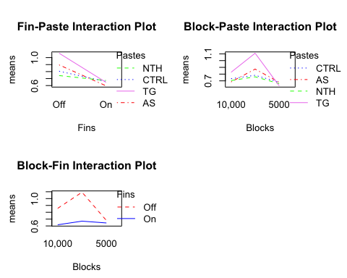

**Graph 2:**

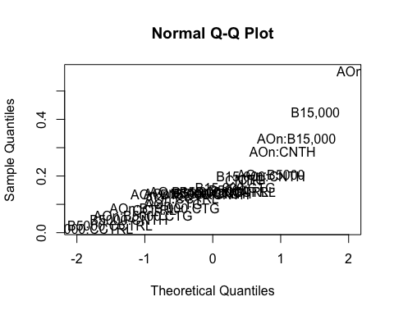

**Graph 4:**

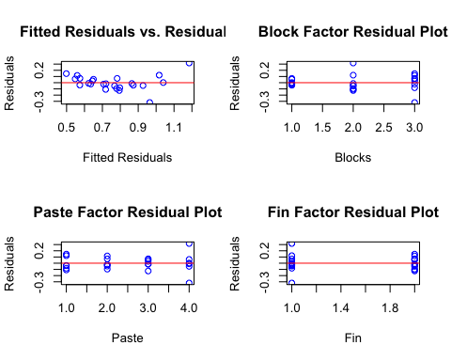

**Graph 5:**

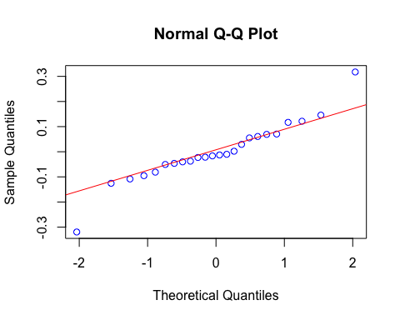

**Graph 6:**

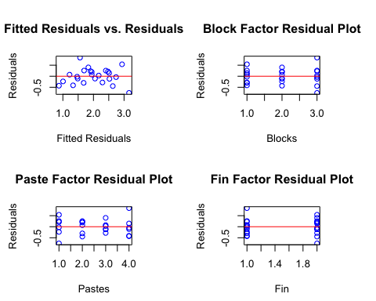

**Graph 7:**

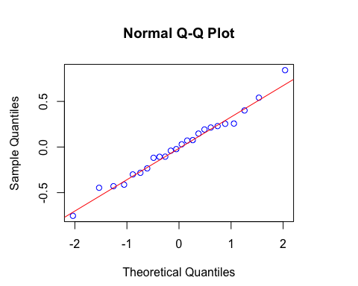

**Graph 8:**

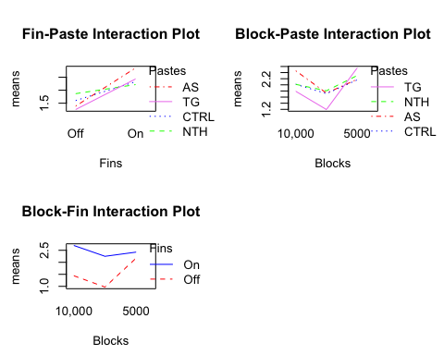

**Graph 9:**



**Graph 10:**

# Bibliography

Swider, Matt. 2016. *techradar.* http://www.techradar.com/news/this-is-how-much-samsung-says-itll-lose-on-the-galaxy-note-7-recall.

Upton, Eben. 2016. *raspberrypi.* https://www.raspberrypi.org/blog/ten-millionth-raspberry-pi-new-kit/.

Wiens, Christopher Wiens & Douglas. 2005. "AN EXPERIMENT IN AIRCRAFT PRODUCTION." *University of Alberta* 11.

**Special thanks :**

**John Fedoruk (MSc UAlberta) – For helping with model verification  
Dr. Simchi – For Rcode used for analysis**

**Bridgette Ng, Bowen Wang – My group members for helping me book rooms to work in.**